ACTIVITIES (2016-17)

S.NO | DATE | NAME OF ACTIVITY | ATTENDED STUDENTS
1 | 20/12/2016 | QUIZ COMPETITION CONDUCTED BY MATHEMATICS DEPARTMENT ON | ALL B.Sc STUDENTS
2 | 22/12/2016 | CELEBRATING SRINIVASA RAMANUJAN’S BIRTHDAY | ALL B.Sc STUDENTS
3 | 22/12/2016 | STUDENT SEMINAR CONDUCTED BY MATHEMATICS DEPARTMENT | ALL B.Sc STUDENTS

QUIZ COMPETITION CONDUCTED BY MATHEMATICS DEPARTMENT ON 20/12/2016
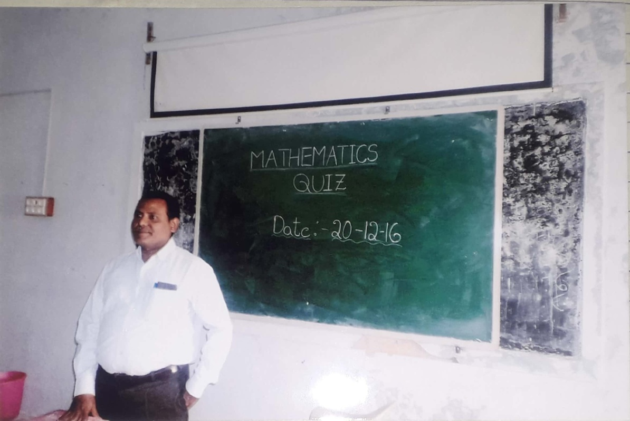

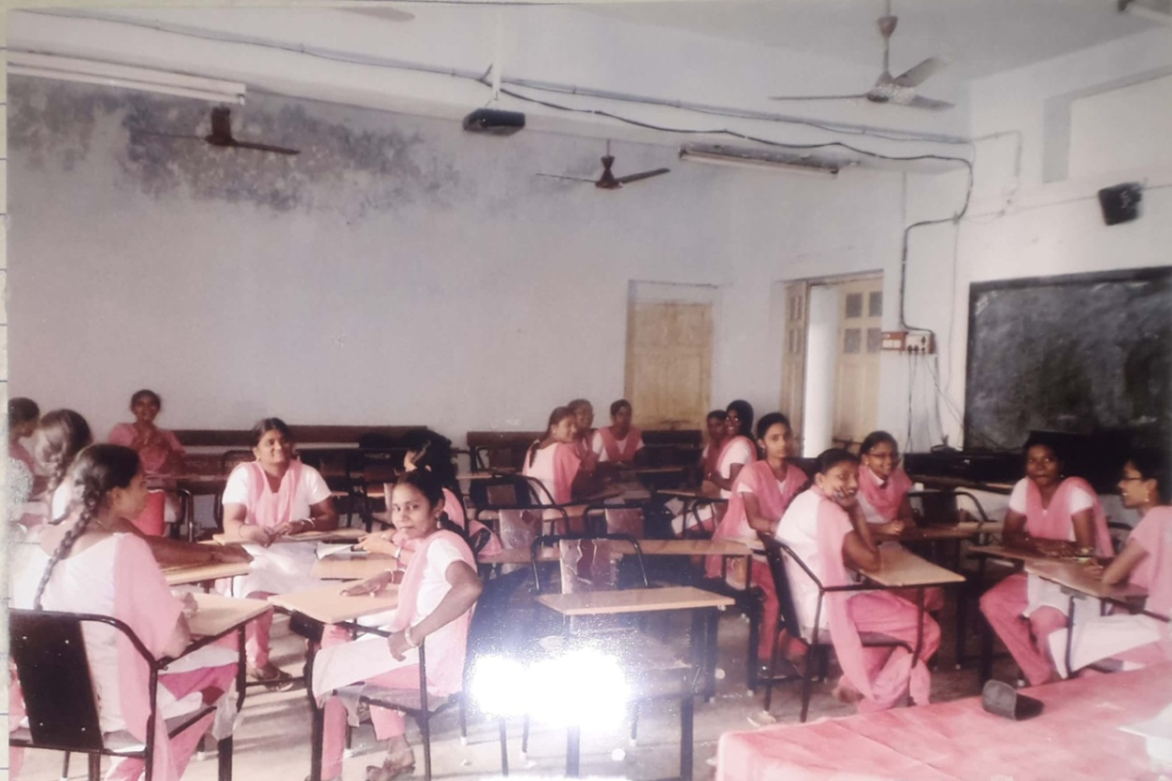
CELEBRATING SRINIVASA RAMANUJAN’S BIRTHDAY ON 22/12/2016

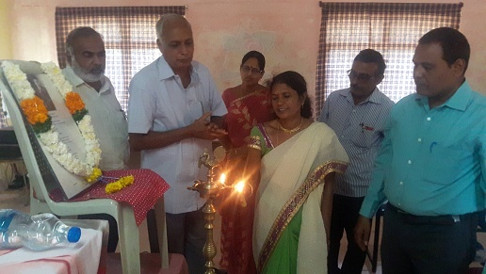

Dr.GIRIJA SANKAR RAO .,Retd LECTURER., V.R.S & Y.R.N COLLEGE ADDRESSING THE STUDENTS ON RAMANUJAN’S BIRTHDAY

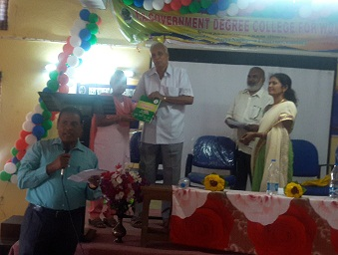

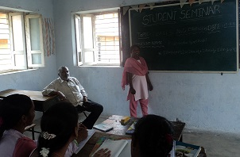
STUDENT SEMINAR CONDUCTED BY MATHEMATICS DEPARTMENT ON

EXTENSION ACTIVITIES BY MATHEMATICS DEPARTMENT

Faculty Forum Talk by Sri Ch. Chandra Sekhar, Lecturer in Mathematics on “Seven Bridges of Konigsberg”

